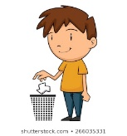
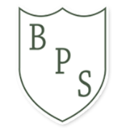
Class Based Risk Assessment
Class carrying out the risk assessment: Year 4 |  | Date: 2nd September 2020
 |  | Review date: January 2021
Hazard | Who might be harmed and how? |  | What can we do to help?
Belongings children and adults bring from home  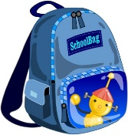 | Children and adults may touch surfaces which have not been cleaned and increase their risk of catching coronavirus |  | 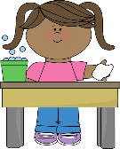  Make sure we are responsible for wiping our water bottles and packed lunches.  We must not bring anything else from home.
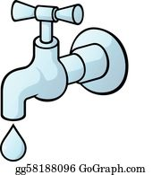  Door handles, taps and other surfaces  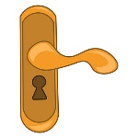 | Children and adults may touch surfaces which have not been cleaned and increase their risk of catching coronavirus |  | 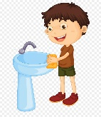  Wash hands regularly and wipe down surfaces. Make sure I go to the toilets when it is Year 4’s time to go.
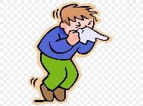  Cough and sneezes | Children and adults may touch surfaces which have been coughed on or sneezed on by children and adults |  | 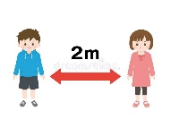  Keep a safe distance from others wherever possible. Catch it, bin it, kill it for coughs and sneezes either in a tissue or in your arm
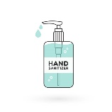  Alcohol hand gel | Children and adults may misuse the alcohol hand gel and become unwell |  | Only use alcohol hand gel provided by school and under the direct supervision of an adult. Use soap and water whenever you can.

